ST. ERVAN PARISH COUNCIL
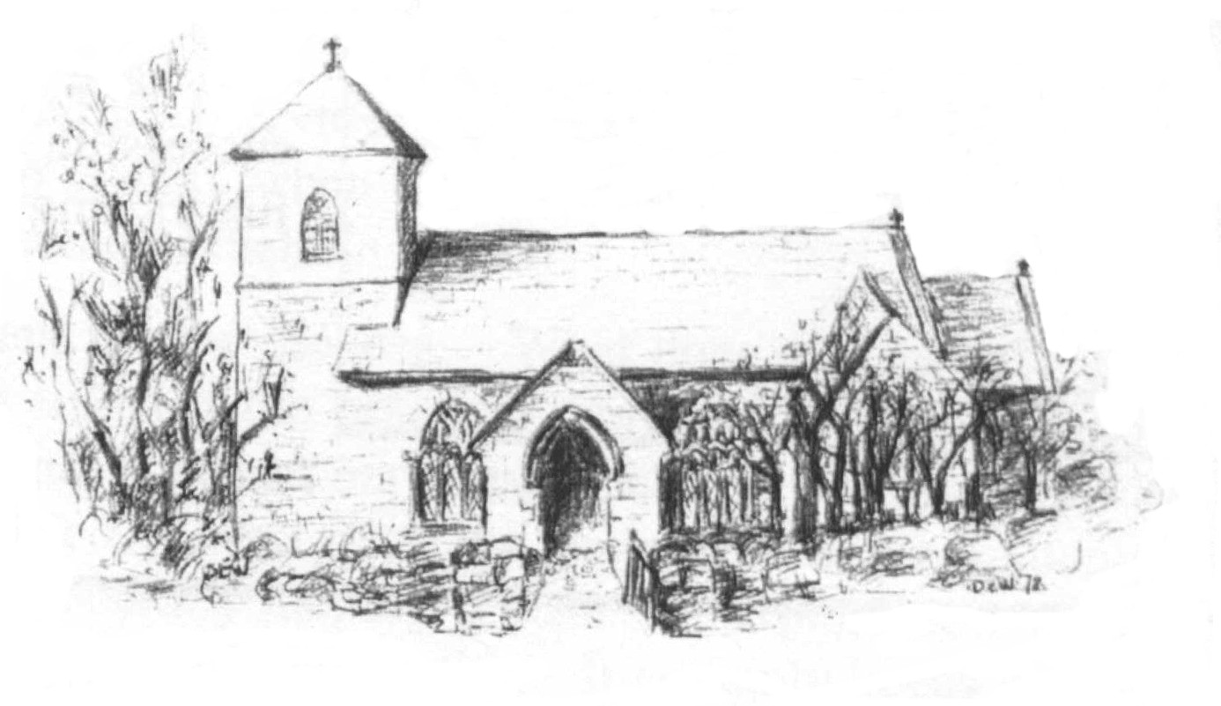
Jacqui Peskett
Parish Clerk
Tel 07835 937261
Email stervanpc@outlook.com

St Ervan Parish Council Meeting Minutes – Tuesday 2nd July 2024 held at St Ervan Village Hall commencing at 7.30 pm.

Present: Cllrs R Biddick (Chair), J Skinner, K Wood, L Clarke, M Biddick, Kent & Eustace.

Also present: Clerk & Cornwall Councillor Stephen Rushworth.

Public Participation: None.

14/24. Apologies and Announcements: None.

15/24. Declarations of interest:
To RECEIVE any Declaration of Interest from Members, to RESOLVE to grant any requests for Dispensation in line with the Councilor Code of Conduct 2021 if appropriate. None.
16/24. St Ervan Parish Council Meeting 7th May 2024
To RESOLVE to adopt the minutes of the meeting held on the above date and having previously been circulated, to be signed. It was proposed Cllr Skinner seconded by Cllr Clarke and resolved that these reflect a true record of the meeting. All in favour – carried.
17/24. Cornwall Councillors report: Cllr Rushworth advised Members that due to forthcoming General Election, he was unable to comment on most matters.
- New refuse arrangements in place from October and he will update at September meeting.
- Enforcement issue be re visited and Police now involved.
- Bearsdown Planning application – objections being looked at.
18/24. Parish Matters arising and Correspondence:
- To RECEIVE the Police report (previously circulated)

- Cornwall Council – footpath diversion Proposed Diversion of Parts of Public Footpaths 538/7 and 539/8 at “Trembleathe Barton” in the Parishes of St Ervan CP and St Eval CP.
It was proposed by Cllr M Biddick seconded by Cllr Eustace and resolved that no further comments were need in respect of this application – all in favour- carried. Confirmation letter to be sent back.

- Cornwall Council footpath diversion- TAD 132: Consultation on 'Proposed Diversion of Part of Public Footpath 17 St Ervan associated with planning application PA23/05460
It was proposed by Cllr R Biddick seconded by Cllr Clarke and resolved that no further comments were need in respect of this application, all in favour – carried. Confirmation letter to be set back.

- Refurbishment of Telephone kiosk at Penrose which has the defibrillator in it. Needs repainting, glass replaced and a general tidy up. No one had come forward to volunteer yet, the Clerk will as Dreckly magazine to re advertise in their August Issue.

- A Parishioner has contacted the Clerk in relation to a footpath between which is classed as “silver” and not part of the current cutting schedule (currently gold paths only). After discussion, it was agreed that the Clerk would obtain costs from their contractor to carry out this extra cut and a decision would be made between Members by email as the PC is not due to meet until September.

19/24. Planning Applications: to CONSIDER Planning Applications or any that may be received since the agenda was published:
Demolition of existing barn and proposed 2 new dwellings - in lieu of the part Q approval PA23/06441
The Nook Bogee Farm Rumford Wadebridge Cornwall PL27 7SQ
Ref. No: PA24/03708 | Received: Thu 09 May 2024 | Validated: Tue 28 May 2024
This application was circulated by email and decided on 17th June 2024.
6 in favour and 1 against – It was proposed by Cllr Kent seconded by Cllr Clarke and resolved that retrospective agreement be given - carried. Comments sent to Planning said “It was noted that the dwellings will be in close proximity to the farmhouse which is listed and the new build is not in character with the surrounding houses. It is not clear whether this will be for residential or holiday use.
Certificate of Lawfulness for existing use for the construction and use of a single dwelling and residential curtilage without compliance with, or implementation of, planning permission referenced PA11/08930.
Trewinnick Lodge Trewinnick Road St Ervan Wadebridge Cornwall PL27 7SL
Ref. No: PA24/04238 | Received: Thu 30 May 2024 | Validated: Thu 30 May 2024
It was proposed by Cllr Biddick seconded by Cllr Skinner and resolved that no further comments were need in respect of this application. All in favour – carried. Comments sent to Planning said “ the Parish Council have no comments to make”.

20/24. Highways To CONSIDER any issues that may have arisen and RESOLVE appropriate action.
- White lines at Rumford Crossroads (PL27 7RT) has been reported however Highways do not see it as urgent. Clerk to continue to monitor.
- Pothole to be reported (PL27 7RU) has been reported and a pothole was repaired however not the one reported. Clerk will report the pothole on the corner again.
21/24. Finance
21.1 To consider and approve donations to the following:
PCC It was proposed by Cllr Eustace seconded by Cllr Clarke and resolved to donate the sum of £500 (five hundred pounds) – all in favour carried.
Cemetery It was proposed by Cllr R Biddick seconded by Cllr Skinner and resolved to donate the sum of £300 (three hundred pounds) - all in favour carried.
Dreckly Magazine It was proposed by Cllr Skinner seconded by Cllr Kent and resolved to donate the sum of £50.00 (fifty pounds) - all in favour carried.

21.2 Payments due:
Clerk Remuneration (2 months) | £266.47
Clerks Expenses (2 months) | £51.25
HMRC/PAYE | £66.60
Gallagher Insurance (Already Paid) | £452.46

Income
Bank Interest | £5.29

It was proposed Cllr Skinner seconded by Cllr wood and resolved that the above payments be made.
22/24. Items for September Meeting. None.

The Chairman closed the meeting at 8.05pm.

Date Of Next Meeting Tuesday 3rd September @7.30pm

Signed………………………………………….

